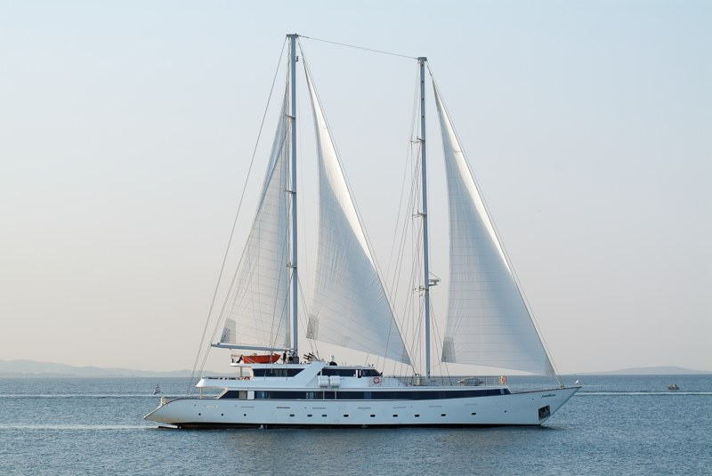
Dodecanese Mosaic 2013
A 7 nights journey from Rhodes
On board the 25 cabin Sail Cruiser S/C Panorama II

Amphitrion Yachting
Experience a harmonious balance between conventional cruising and private yachting, along with an exciting voyage of discovery, unravelling the wonders of Crete and of the Eastern Aegean. Visit world -famous Rhodes, Santorini and Bodrum in Turkey and the laid back and «Old Greece «islands of Karpathos or Amorgos. Each day you will discover a new port of call, a hidden cove with crystal blue waters to cool you, a glimpse of ancient history to amaze you and rich cultural diversity to intrigue you.

The Sailing Cruiser Panorama II
The PANORAMA was launched in 2004. This state of the art sail cruiser has performed several Atlantic Ocean crossings, has sailed from the Seychelles to Monte Carlo and from the Black Sea to Tunis and offers the highest standard of accommodation, comfort and safety.

Life on Board
During the day, life on board centers around the outdoor areas including the 2 bars and the sun deck. In the evening you can relax in one of the ship’s two lounges, the library, and enjoy a drink while listening to piano music. The swimming platform on PANORAMAII ’s stern enables you to swim when weather and anchorage conditions permit.

The Cabins
The PANORAMA II ’s cabins are located on 3 decks and are finished with wooden furniture and light fabrics. Cabins on the Upper and main decks are equipped with windows while cabins on the lower deck have portholes. The fully equipped bathrooms are finished with marble. All cabins are air-conditioned and fitted with TV, telephone (for internal use), hairdryers, mini-fridge, central music, public address system and safe boxes.

Dodecanese Mosaic 2013 Rhodes - Rhodes - on Tuesdays
NO | PORT | COUNTRY | PROGRAM - EXCURSIONS | ARR | DEPT
1 | Rhodes | Greece | Embarkation Rhodes 14.00 to 15.00 hrs. - Sailing to Symi. |  | 15:00
 | Symi | Greece | Swim stop on the way in a Symi Bay.  Evening arrival in port of Symi. Overnight in Symi. | 17:00
2 | Symi/Bodrum | Greece | Early morning sailing to Bodrum. Excursion.  Overnight at sea to Amorgos. |  | 5:00
3 | Amorgos | Greece | Early morning swim stop in Amorgos Bay.  After lunch, arrival in Amorgos. Overnight in port. | 8:00
4 | Amorgos/Ios | Greece | Early morning sailing to Ios - Manganari for swim stop.  After lunch, arrival in Santorini. |  | 6:00
 | Santorini | Greece | Afternoon excursion. Late in the evening we leave Santorini and sail overnight to Crete, Aghios Nikolaos | 13:30 | 23:30
5 | Aghios Nikolaos | Greece | Early morning arrival in Crete. Excursion to Knossos. Afternoon sailing to Vai. | 7:00 | 16:00
 | Vai Forest | Greece | Swim stop. Overnight at anchor in Vai Bay. | 19:00
6 | Vai Bay | Greece | Early morning sailing to Karpathos. |  | 5:00
 | Karpathos | Greece | Swim stop near Karpathos. Arrival mid day after BBQ. Afternoon excursion. Overnight at sea to Lindos/Rhodes. |  | 0:00
7 | Lindos/Rhodes | Greece | Early morning arrival in Lindos. At anchor - Swimming or morning excursion in Lindos.  Mid day sailing to Rhodes town. | 8:00 | 12:30
 | Rhodes | Greece | Rhodes town. Overnight in port. | 18:00
8 | Rhodes | Greece | Disembarkation 9:00 hrs.

Itineraries can be changed at the discretion of Amphitrion Yachting and of the Vessel's Captain in case of adverse weather conditions - winds of 6/7 beaufort or more depending on the vessel- on port authorities not allowing a vessel to leave port or in case of other extraordinary conditions. Such itinerary changes do not entitle automatically passengers to any refunds but Amphitrion Yachting guarantees that passengers are disembarked at the advertised port of disembarkation on time for their flights.

The Dodecanese Mosaic 2013
8 DAYS CRUISES
On board the 25 cabin Sail Cruiser S/C Panorama II

SAILINGS DATES & OFFICIAL EURO RATES
From Rhodes  Tuesday Sailings | 7, 14, 21, 28 May  4,11, 18, 25 June  2, 9, 16, 23, 30 July  6, 13, 20, 27 August 3, 10, 17, 24 September
CABIN CATEGORIES | OFFICIAL EURO RATES
Cat C  Lower Deck, Double bedded cabins | € 1,400
Cat B  Lower Deck, Twin bedded cabins | € 1,650
Cat A  Main or Upper Deck, Double or Twin bedded cabins | € 2,200
Reduction for 3rd person in Cat. B | 30%
Single Supplement | 50%
Port Charges | € 170

* Red Star Marked Dates have a discount of 10%

A/ Cruise fares are per person and week and include
- Accommodation in double or twin cabins with private SH/WC & air conditioning.
- Half-board: American buffet breakfast and one daily meal, including a Welcome Cocktail, and Captain’s Dinner.
- Regular (filter) coffee, tea and still mineral water free all day.
- Use of fishing and snorkelling equipment (subject to availability).
- Multilingual Cruise Escort.

Not included:

- Beverages (except those mentioned above).
- Shore excursions on the islands or other land arrangements.
- Crew tips.
- Passenger personal expenses.

HONEYMOON PACKAGE – DESCRIPTION, CONDITIONS AND RESTRICTIONS

1/The Honeymooners Package features:

- 25 % reduction for the bride
- Cabins with Double or King bed
- Welcome Honeymooners treatment including a Complimentary bottle of Champagne and a Fruit Basket;
- A Candle Lit Dinner at our Special Honeymooners location on board our ships (for all our programs outside Greece ) or at a preferred restaurant in Santorini or Mikonos for our Greek cruise programs;
- 10% discount for any wedding anniversary on board our ships;
- Automatic access to our Variety Club membership;
- “ Our Memories” gift at disembarkation;
- A free 1/2 hour massage for 2, if on board our Harmony V, Variety Voyager and Seychelles program vessel.

NOTES

1. Please ask the details for our "Wedding and Cruise with friends and family" private charter for 40 to 72 guests.
2. This package is also available to clients wishing to renew their vows. The Vows renewal ceremony is performed by our Ship Captains.

2/ Honeymoon offers : General conditions and restrictions
a/ The Honeymoon offer is valid only provided that the couple is traveling within 6 months from their wedding date (copy of marriage certificate required);
b/ The Package cannot be combined with any existing or future SPECIAL OFFERS.

B/ Conditions and restrictions

PROOFREADING Tour Operators featuring our Cruises in their Catalogue or Internet site by itinerary, vessel’s description and images, will send VARIETY CRUISES a draft for error-checking of the contents prior publication as well as two brochure copies when printed. In order to secure corect information given to our clients and keep our high customer satisfaction levels. Amphitrion Yachting will not bare any responsibility for innacurate information or misrepresentation of our vessels or cruise itineraries without having accepted a draft prior to the brochure going to print or internet page published.

PAYMENT 25% deposit is required upon confirmation. Balance of payment is due no less than 60 days prior to day of embarkation.

CHILD REDUCTION Children between the ages of 7-10 sharing a cabin with two paying adults receive a 50% discount. Children between the ages of 10-16 sharing a cabin with two paying adults receive a 35% discount. Port taxes are not discounted.

CANCELLATIONS 25% of the cruise for any written cancellation received between 60 to 31 days prior to sailing; 50% up to 16 days prior to sailing; full cruise fare for written cancellations received less than the 16th day prior to sailing or for “no shows” even if cancellation is due to unforeseen circumstances beyond passenger’s control. Cancellations must be confirmed by AMPHITRION YACHTING in writing in all cases.

AMENDMENTS There may be a charge for amendments of cruise date or decreasing guest numbers received less than 60 days prior to sailing. Amendments must be confirmed by AMPHITRION YACHTING in writing.

NOT INCLUDED IN CRUISE FARE Such personal expenses as drinks (other than included in the rate), laundry and gratuities, (gratuities are optional but as a rule, satisfied clients are
expected to give to the captain, at the end of the cruise, approximately Euro 8.00-10.00 p/p p/day for distribution among crew members) medical expenses, port taxes, shore excursions (shore excursions are proposed and arranged on board by the tour leaders) expenditures incurred ashore, and anything not mentioned in cruise program.

